New cell death mechanism has implications for breast cancer treatments

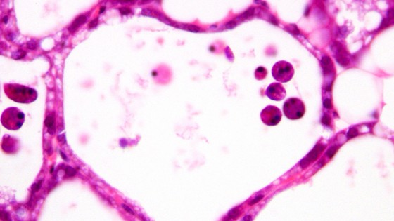

A novel mechanism of cell death that occurs in mammalian organisms has been revealed by researchers at the University of Cambridge.

Billions of damaged or superfluous cells die in our bodies every day.

It is thought that most cell death occurs by a process called apoptosis, in which biochemical events lead to cell changes and death.

However, during the course of Peter Kreuzaler’s PhD research at the Department of Pathology, the Cambridge team have shown that cells in the breast die following lactation by a process that involves lysosomes – organelles which digest and recycle cellular components.

As the mammary gland regresses, enzymes called cathepsins leak out of the lysosomes into the cell and induce cell death.

This is the first time that this type of cell death has been shown to occur in a healthy mammal: the original work was done in vivo in mice.

Additionally, the protein Stat3, which is present in high levels in cancers that have poor prognosis, plays a significant role in lysosomal-mediated programmed cell death as it induces high levels of cathepsins while suppressing cathepsin inhibitors.

Describing how the work was done, Professor Christine Watson of the Department of Pathology said: “We found a gene that was hugely down-regulated by Stat3.”

This gene inhibits lysosomal enzymes, so [we] started looking at these.”

The team’s findings will cause scientists to think differently about how cells die.

Kreuzaler added, “Our work is the first to show that a lysosomal pathway of cell death occurs in a normal situation in the body.

Current cancer research focuses on understanding how cancers evade cell death.

The discovery of a novel pathway of cell death is likely to explain a yet unexplained tumour resistance to cell death, while giving researchers new prospective therapeutic targets.”

According to Watson, the most exciting thing about this work is that the team have identified a new form of cell death that has major implications for cell death research and for treating people with breast cancer.

The research, recently published in the journal Nature Cell Biology, was funded by studentships from the Department of Pathology and the Breast Cancer Campaign, as well as the Biotechnology and Biological Sciences Research Council and the Medical Research Council.

The next steps will be to take advantage of this as a death pathway in breast cancer in particular, and to see how this pathway actually operates and is controlled.

She plans to investigate whether the same process works to kill cancer cells in culture.

While a treatment based on this new cell death mechanism is far in the future, Watson thinks that a therapy based on lysosomal-mediated cell death could target very aggressive cancers.